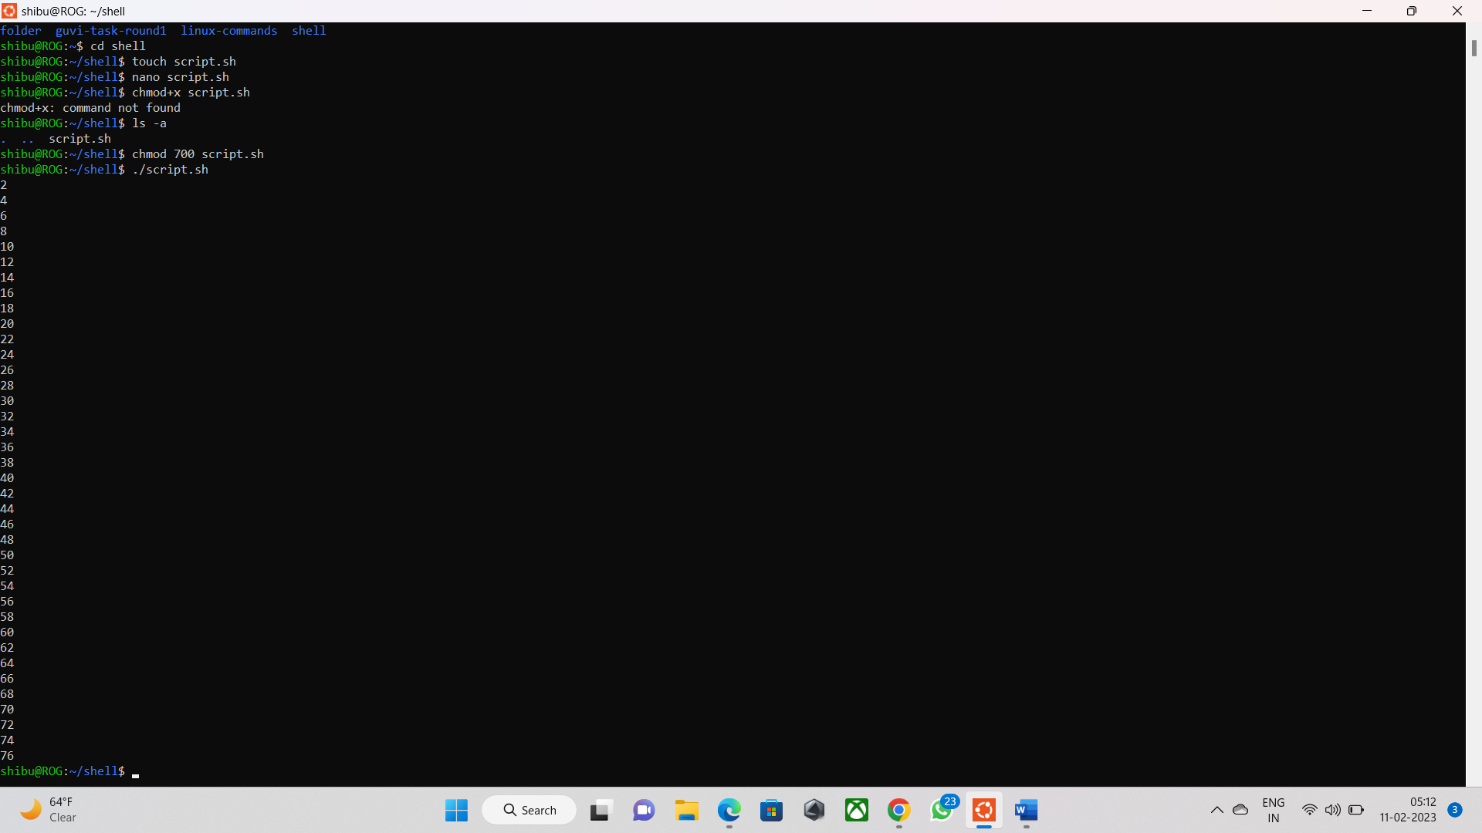

Welcome to Ubuntu 22.04.1 LTS (GNU/Linux 5.10.16.3-microsoft-standard-WSL2 x86_64)

* Documentation: https://help.ubuntu.com

* Management: https://landscape.canonical.com

* Support: https://ubuntu.com/advantage

This message is shown once a day. To disable it please create the

/home/shibu/.hushlogin file.

shibu@ROG:~$ ls

folder guvi-task-round1 linux-commands

shibu@ROG:~$ mkdir

mkdir: missing operand

Try 'mkdir --help' for more information.

shibu@ROG:~$ mkdir shell

shibu@ROG:~$ ls

folder guvi-task-round1 linux-commands shell

shibu@ROG:~$ cd shell

shibu@ROG:~/shell$ touch script.sh

shibu@ROG:~/shell$ nano script.sh

shibu@ROG:~/shell$ chmod+x script.sh

chmod+x: command not found

shibu@ROG:~/shell$ ls -a

. .. script.sh

shibu@ROG:~/shell$ chmod 700 script.sh

shibu@ROG:~/shell$ ./script.sh

2

4

6

8

10

12

14

16

18

20

22

24

26

28

30

32

34

36

38

40

42

44

46

48

50

52

54

56

58

60

62

64

66

68

70

72

74

76

shibu@ROG:~/shell$